

**Fortune 500**

Fortune 500 is a list of 500 of the largest companies in the United States compiled by Fortune Magazine every year. Companies are ranked by their annual revenues for their respective fiscal years. The list includes both public and private companies using publicly available revenue data. Due to COVID-19, the global 500 shrank a little compared to the past year, 2020. After reaching a record high of $33.3 trillion in the 2020 edition, total revenue for the world’s biggest companies fell by 4.8% to $1.37 trillion in 2021. However, the combined sales of the companies on the list are equal to more than one-third of global GDP.

The companies belong to various sectors. We have identified and classified 4 sectors for our analysis:

**Technology and Telecommunication:**

This sector covers a large range of businesses involved in developing, manufacturing, and providing technology-related products and services. Companies in this sector are crucial players in driving innovation, digital transformation, and connectivity across industries and society. This sector is a major driver of economic growth and job creation across the globe.

**Finance:**

The Finance sector encompasses a wide range of businesses involved in managing financial assets, providing banking and investment services, offering insurance products, facilitating payments, and more. The Fortune 500 companies are instrumental in shaping the global financial landscape and supporting economic activities and financial well-being worldwide.

**Food and Beverages:**

Companies under the food and beverage umbrella manufacture, distribute, and sell food and beverage products. This sector is a significant contributor to employment and economic growth in various regions. These companies play a pivotal role in meeting consumer needs and shaping culinary trends globally.

**Health and Pharmaceuticals:**

The health and pharmaceutical sector includes a broad range of companies that are focused on the research, development, manufacturing, and distribution of healthcare products and services. It plays a crucial role in improving public health, treating diseases, and advancing medical innovation.

**This Report is focused on comparing the ROA of Fortune 500 companies in 2021. The companies have been classified into the following major sectors:**

**1. Technology and Telecommunication**

**2. Finance**

**3. Food and Beverage**

**4. Health and Pharmaceutical**

**Two methodologies have been employed to carry out these comparisons:**

**1. Comparative Analysis:** Descriptive statistics, histograms, and box plots have been used to understand the quantitative and visual differences between ROAs of different companies under different sectors.

**2. Regression Analysis:** Correlation between ROAs and no. of employees in a firm as well as market values is obtained and a model is built to relate the variables. The usefulness of the model is then tested by using a different data set

**COMPARATIVE ANALYSIS:**

**Descriptive Statistics: (RO values are in %)**

|  |  |  |  |  |
| --- | --- | --- | --- | --- |
|  | **Technology and Telecommunication** | **Finance** | **Food and Beverage** | **Health and Pharmaceutical** |
| **Mean** | 10.360 | 2.114 | 100.186 | 5.223 |
| **Standard Error** | 1.450 | 0.838 | 93.027 | 1.549 |
| **Median** | 10.301 | 0.791 | 7.436 | 6.215 |
| **Standard Deviation** | 6.151 | 3.556 | 394.681 | 6.570 |
| **Sample Variance** | 0.378 | 0.126 | 1557.728 | 0.432 |
| **Kurtosis** | -83.725 | 618.491 | 1799.394 | 203.867 |
| **Skewness** | 1.931 | 250.667 | 424.163 | -32.744 |
| **Range** | 22.256 | 14.442 | 1685.007 | 29.536 |
| **Minimum** | -0.596 | -1.014 | -3.472 | -9.066 |
| **Maximum** | 21.660 | 13.428 | 1681.535 | 20.469 |
| **Sum** | 186.471 | 38.047 | 1803.343 | 94.014 |
| **Count** | 18 | 18 | 18 | 18 |
| **Coefficient of Variation** | 59.380 | 168.247 | 393.949 | 125.794 |

A descriptive stats table is a valuable tool for summarizing, analyzing, and communicating key aspects of a dataset. It streamlines data interpretation, enables meaningful comparisons, and supports informed decision-making across various domains and disciplines. The main measures that we are particularly interested in comparing the values are:

**Mean:**

The mean is a fundamental statistical measure that summarizes the central tendency of a dataset. It helps us understand the typical value or level of a given set of data. Technology and Telecommunication: The average return is 10.36%. Finance: The average return is 2.11%. Food and Beverage: The average return is higher than other sectors. Health and Pharmaceutical: The average return is 5.22%.

**Median:**

The median represents the middle value in the dataset. It is less affected by extreme values compared to the mean.Notable differences exist between mean and median, suggesting potential skewness due to outliers.

**Standard Deviation**:

Technology and Telecommunication and Health and Pharmaceutical sectors have relatively similar standard deviations (6.15% and 6.57%, respectively), indicating similar levels of risk or volatility. Finance shows lower volatility (3.56%). Food and Beverage has an extremely high standard deviation (394.68%) and variance (1557.73%), suggesting very wide fluctuations in returns.

**Skewness:**

Skewness measures asymmetry in the distribution.Positive skewness in Technology Telecommunication and Finance suggests a tail extending towards higher returns.Negative skewness in Health and Pharmaceuticals indicates a tail toward lower returns.Food and Beverage has a highly positive skewness (424.16%), indicating a distribution skewed towards higher returns.

**Range, Minimum, and Maximum:**

Technology and Telecommunication and Finance sectors have moderate ranges in returns.The Food and Beverage sector shows an exceptionally wide range (1685.01%), with significant variability in returns. Health and Pharmaceutical sector has a narrower range, with returns between -9.07% to 20.47%**.**

**Coefficient of Variation:**

The coefficient of variation (CV) is the ratio of the standard deviation to the mean, expressed as a percentage. It measures the relative variability of returns across sectors. Food and Beverage has the highest coefficient of variation (393.949%), indicating the highest relative variability in returns compared to its mean. This suggests higher risk and volatility.

**Histograms:**

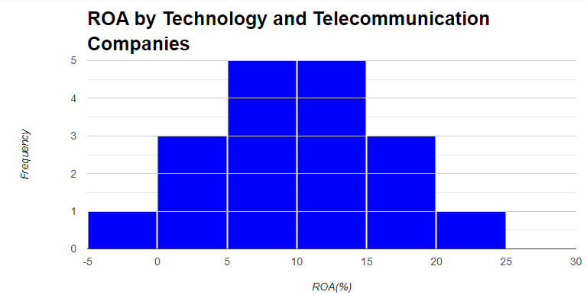

* 5 companies have returns from 5-10% and another 5 have returns between 10-15%.
* The histogram shows that ROA’s were normally distributed among Technology and Telecommunication companies.

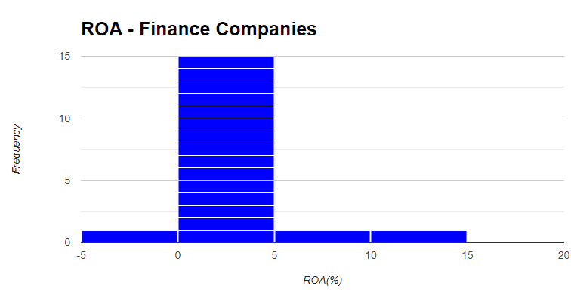

* Most of the companies in the Finance sector had returns between 0-5% in 2021.
* The histogram shows positive skewness.

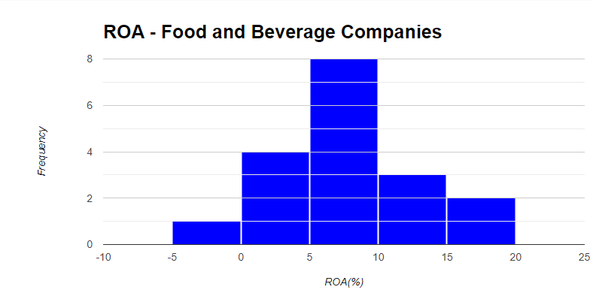

* Most of the food and beverage companies have their rates of return between 5-10%
* The distribution of the graph appears to be almost normally distributed.

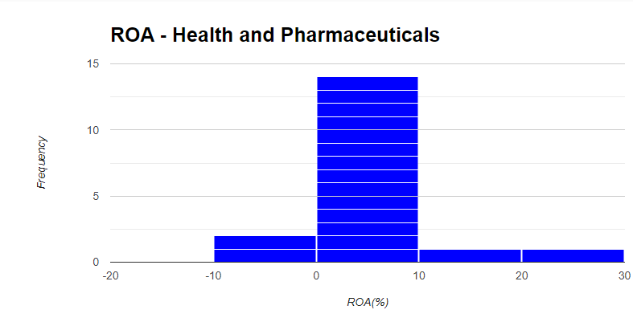

* 14 out of 18 companies have their rate of returns between the 0-10% range.
* The data is highly positively skewed.

**Boxplots:**

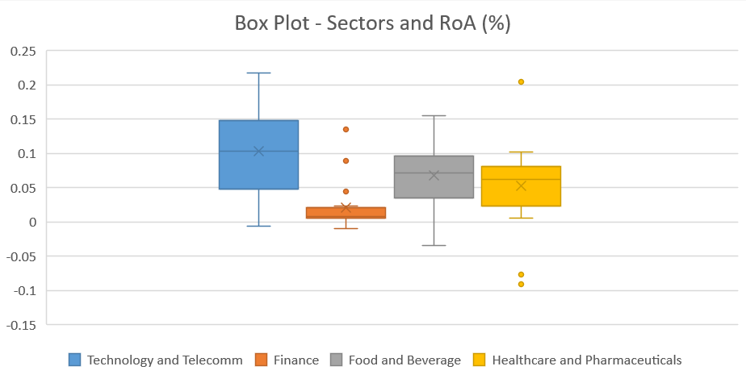

* **Finance** appears to be highly positively skewed if we consider the boxes and negatively skewed if we look at the whiskers. It has 3 outliers. A few companies have exceptionally high returns on assets (ROA), pulling the mean upwards, while the presence of outliers suggests significant variability in ROA among companies in this sector. Some financial companies may engage in high-risk activities or experience windfall profits during certain market conditions, causing a few outliers with significantly higher ROA values. Outliers may result from extraordinary events such as successful investments, regulatory changes, or one-time gains.
* **Food and Beverage** appears to be positively skewed and it has one outlier at approximately 16.81% which is outside the scale of the diagram. The positive skewness in this sector may be attributed to the presence of a few companies with exceptionally high ROA values, likely due to successful product innovation, effective cost management, or strong brand recognition. Most companies in the food and beverage industry may operate within relatively narrow profit margins, leading to a clustering of ROA values towards the lower end of the scale and a few outliers at the higher end.
* **Healthcare and Pharmaceuticals** appear to be negatively skewed and it has around two outliers. This could be due to the predominance of companies with relatively high and stable profitability, resulting in a clustering of ROA values towards the higher end of the scale. However, the presence of outliers with exceptionally low ROA values suggests variability in performance among healthcare and pharmaceutical companies, which could stem from factors like regulatory challenges, research and development costs, or patent expirations.
* The slightly negative skewness in the **Technology and Telecommunication** sector may indicate that a majority of companies have relatively stable and moderate to high ROA values, resulting in a clustering of data towards the higher end of the scale. The absence of outliers suggests that technology and telecommunication companies generally maintain consistent profitability levels, with fewer instances of extreme performance deviations compared to other sectors.

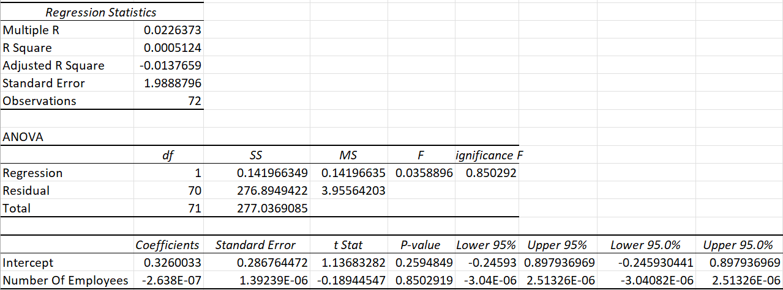**Regression Analysis (No. of Employees):**

The estimated regression equation is:

**ROA=0.326003264−2.63783×10−7×Number of Employees**

**Regression Line (No. of Employees):**

1. **Intercept Interpretation:**

* For a hypothetical firm zero number of Employees, the estimated average Return on Assets (ROA) is 0.326%, approximately 32.6%. However, it's important to note that this scenario is unrealistic as all companies have some employ staff. This intercept value serves as a baseline for comparison rather than a practical scenario.

1. **Slope Employees Interpretation:**

* The estimated coefficient for the Number of Employees indicates that a one-person increase in the Number of Employees is associated with a slight decrease of 2.63x10-7% in ROA.

1. **R-squared (R²) Interpretation:**

* The R-squared value of 0.000512 indicates that only 0.05% of the variation in ROA is explained by the number of employees in the model. This low R-squared value suggests that the model, is not effective in explaining the variation in ROA among Fortune 500 companies. Other unaccounted-for factors likely play a more substantial role in determining ROA.

1. **Correlation Coefficient(r) Interpretation:**

* The weak positive correlation Number of Employees, and Return on Assets (ROA) among the Fortune 500 companies suggests a limited linear association. Additionally, correlation does not imply causation, emphasizing the need for caution in interpreting these relationships.

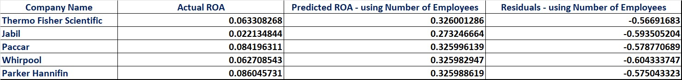**Test of Model**

**Thermo Fisher Scientific – Predicted RoA using Employees:**

**Y =0.326003264−2.63783×10−7×84362= 0.326001**

**Residual = Actual ROA – Predicted ROA = 0.0633-0.326001 = -0.5669**

**Regression Analysis (Market Value):**

The estimated regression equation for:

**ROA=0.344131347−2.22054×10−7×Market Value($ millions)**

**Regression Line (Market Value):**

1. **Intercept Interpretation:**

* In a hypothetical scenario where a firm has zero Market Value, the estimated average Return on Assets (ROA) is 0.344%, or approximately 34.4%. It's important to acknowledge that this situation is not realistic since all companies inherently possess some market value. This intercept value serves as a baseline for comparison rather than a practical scenario.

1. **Market Value Interpretation:**

* The estimated coefficient for Market Value indicates that a one million increase in Market Value is associated with a slight decrease of 2.22x10-7% in ROA.

1. **R-squared (R²) Interpretation:**

* The R-squared value of 0.000194 suggests that only 0.02% of the variation in ROA can be explained by changes in market value within the model. This low R-squared value indicates that the model is ineffective in elucidating the variation in ROA among companies based solely on market value. Other unaccounted-for factors likely play a more significant role in determining ROA outcomes.

1. **Correlation Coefficient (r) Interpretation:**

* The weak positive correlation between Market Value and Return on Assets (ROA) among companies suggests a limited linear association. Additionally, correlation does not imply causation, highlighting the importance of cautious interpretation regarding these relationships.

**Test of Model:**

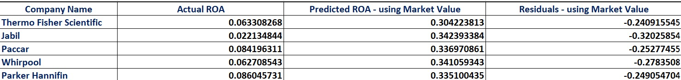

**Thermo Fisher Scientific – Predicted RoA using Market Value:**

**Y =0.344131347−2.22054×10−7×179719 = 0.30422**

**Residual = Actual ROA – Predicted ROA = 0.0633-0.3042 = -0.2409**

**R- Component**

Histograms and Box Plot were made again using R programming

**Histograms in R:**

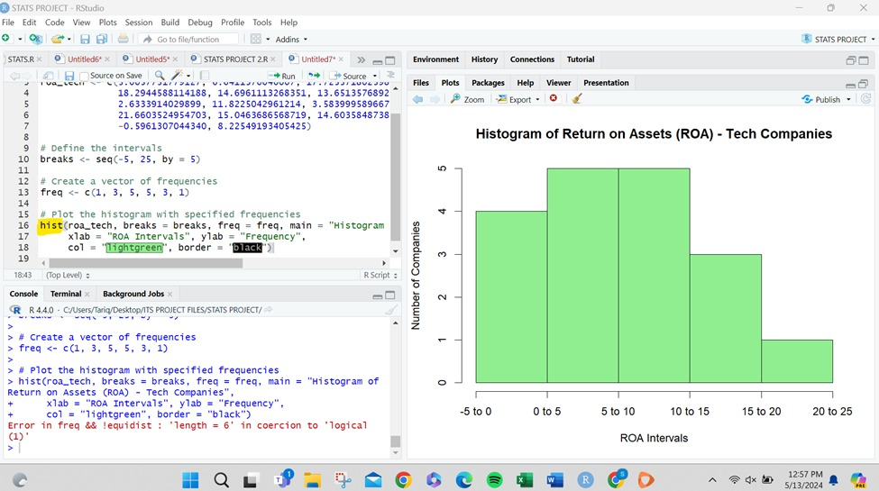

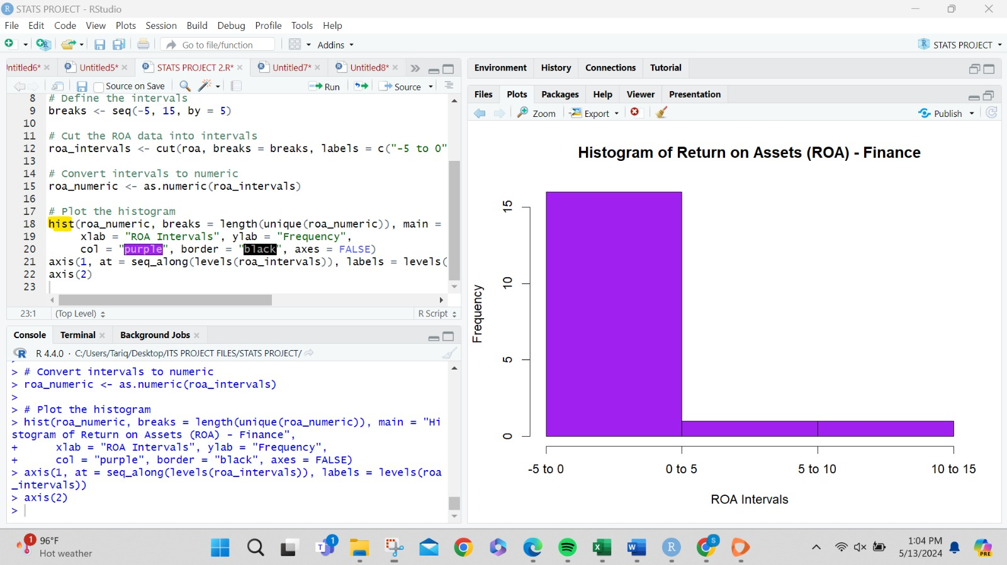

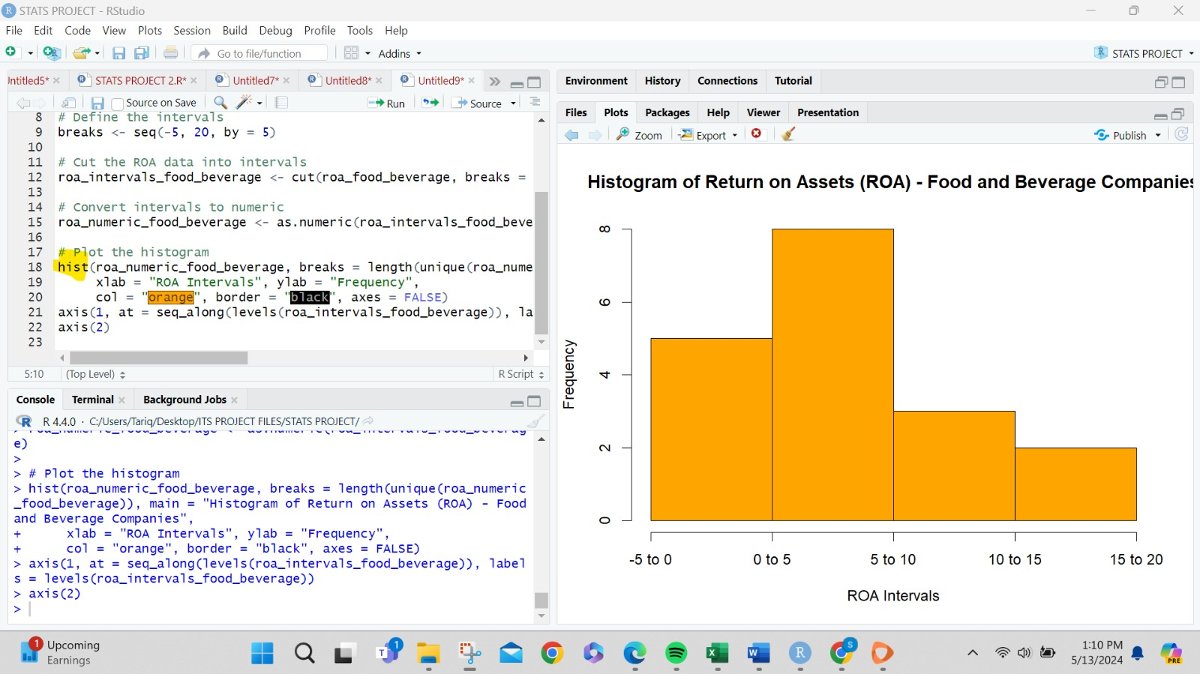

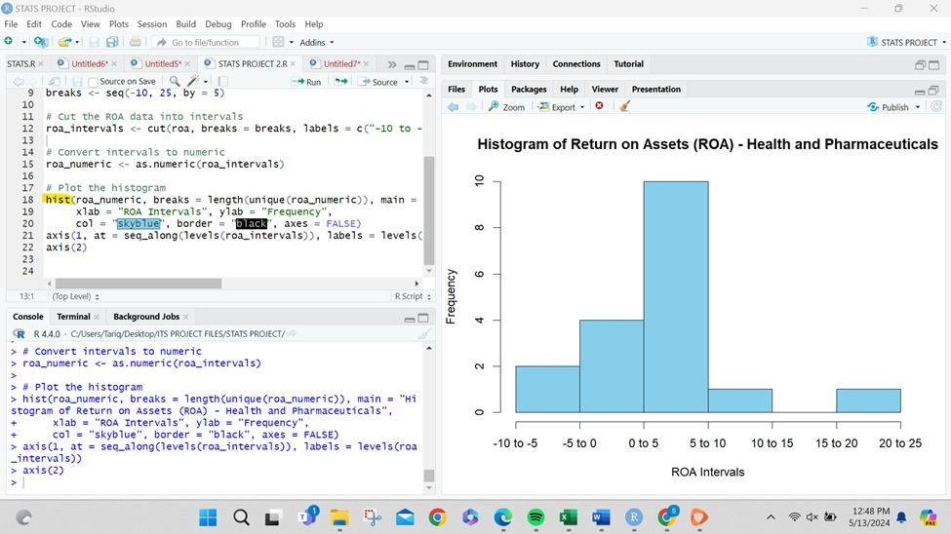

**Boxplot in R**

